MODULE 4 – INTRODUCTION TO DBMS

LAB EXERCISES

2. SQL Syntax
Lab 1.
Write SQL queries to retrieve specific columns (student_name and age) from the students table.
Ans.
1. SELECT student_name, age FROM `student`
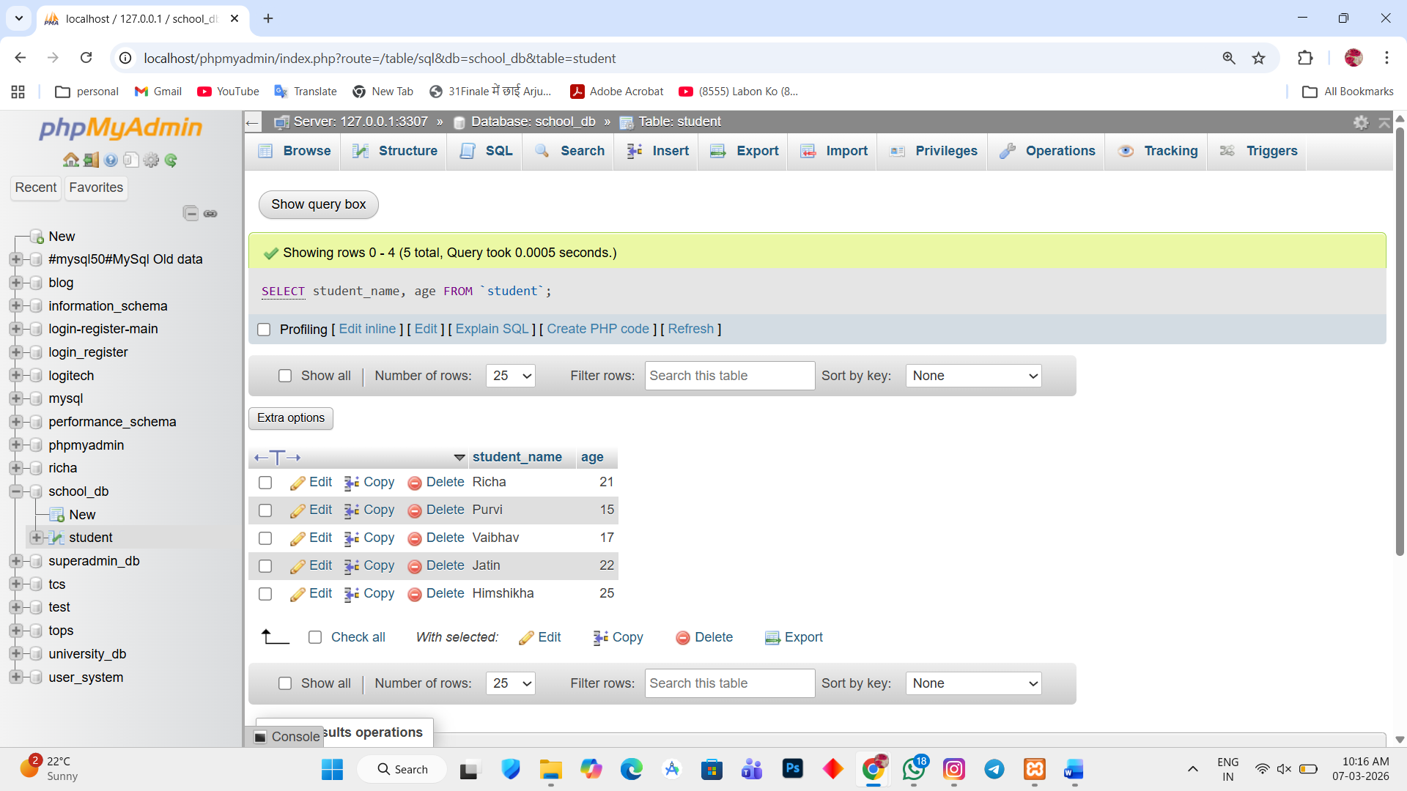

Lab 2.
Write SQL queries to retrieve all students whose age is greater than 10.
Ans.
1. SELECT age FROM `student` WHERE age>10
